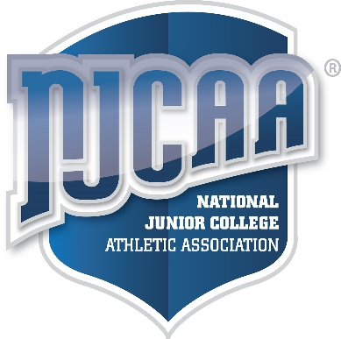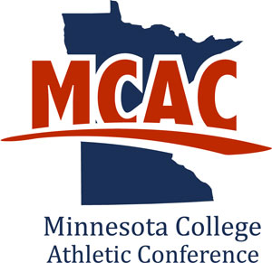

**Divisional Player-of-the-Week**

Director: Peter J. Watkins

Head Coach:________________________

**The MCAC, a member of NJCAA DIII, with teams located in Minnesota and Wisconsin** Anoka-Ramsey ● Central Lakes ● Fond du Lac ● Hibbing ● Itasca

Mesabi Range ● Minnesota West ● M State-Fergus Falls ● Northland ● Rainy River

Ridgewater ● Riverland ● Rochester ● St. Cloud ● Vermilion ● Western Tech

**Kirk Gibson, *Week of March 10th- 16th***

Detriot Tigers Community College

**2018 Baseball**

**Northner Divsion**

*Minnesota College Athletic Conference*