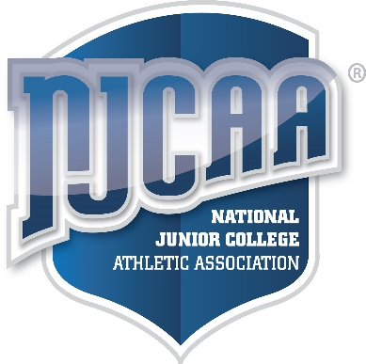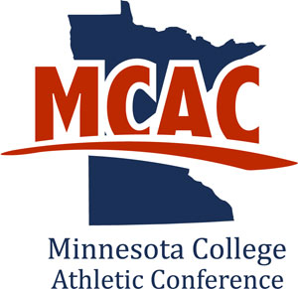

**<student-athlete name>**

< Sample Community College>

**The MCAC, a member of NJCAA DIII, with teams located in Minnesota, North Dakota and Wisconsin** Anoka-Ramsey ● Central Lakes ● Dakota College – Bottineau ● Fond du Lac ● Hibbing ● Itasca ● Lake Superior

Mesabi Range ● Minnesota West ● M State-Fergus Falls ● North Dakota State College of Science ● Northland ● Rainy River

Ridgewater ● Riverland ● Rochester ● St. Cloud ● Vermilion ● Western Technical

Director: Peter J. Watkins

Head Coach:________________________

**2017-18**

**Team Academic Award**

**Women’s Basketball**

*Minnesota College Athletic Conference*